HIST49S

Special Topics:

Soviet, Russian & Post-Soviet History in the World System; Imperialism, Communism and Nationalism through TEXTS, ART, and POPULAR CULTURE
2026 Summer Term Course Syllabus Proposal

Ana Dević Associate Professor
University of Bologna and KU Leuven
Emails : ana.devic@kuleuven.be & ana.devic@unibo.it
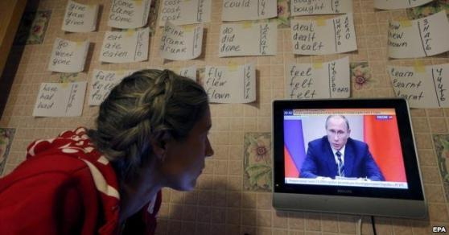

Young woman watching Russian news as she practices English
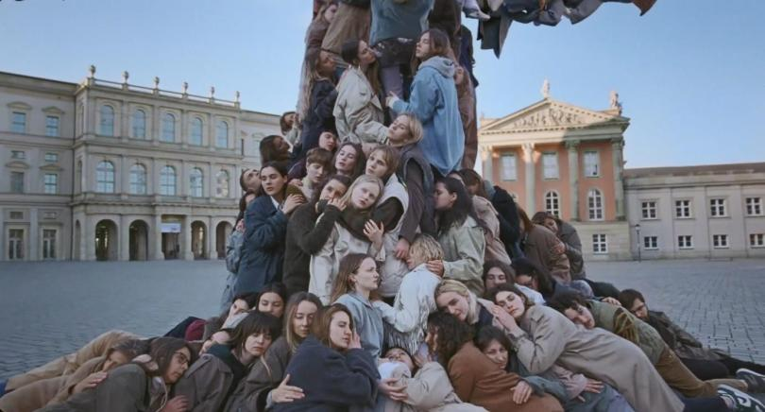

“Uprooted,” a short film released by UNHCR, the UN Refugee Agency, ahead of the World Refugee Day on 20 June 2022: Ukrainian refugees in Berlin depict the trauma of fleeing the war

Nota bene:
• Once a week (hours to agree upon with the students) we may have extra two hours (from 17 to 19h), normally for watching the films whose contents require clarification/ explanations).
This course addresses the history of Soviet socialism/ communism and the “leap” from communism to democracy-and-capitalism after the end of the Cold War and the fall of the Berlin Wall in 1989. These will be situated in the global processes of the declining and nationalizing empires since the late 19th century, the war violence of WWI and WWII, the rise and fall of the fascist and Nazi regimes, and the revolutionary expansion of the communist regimes from the USSR westward in Eastern and Southeastern Europe. The main tools of addressing these processes will be historical and social science research methods, as well as the arts (literature and popular culture, especially cinema).

The course will, first, examine, the political and social history of the Russian empire, leading to the first communist revolution -- the 1917 October Revolution, which initially pursued the program of liberating the poorest and most marginalized groups in the society -- the workers, rural ethnic minorities, and women – through the hitherto unseen in its scale programs of literacy and education, industrialization and urbanization, where the development of cinema and avant-garde art forms played one of the critical roles.
We shall study the Soviet and post-Soviet history through literature, cinema and other media, focusing mostly on the Russian Federation, Ukraine, Central Asian and Caucasus regions, and seeking to understand the following radical processes: the sweeping social homogenization (the “abolition of classes”) that took place after the communist October revolution in 1917 and the Civil War, the rapid industrialization with urbanization and forced collectivization of peasants and agriculture (with its tragic social costs, such as the famines), radical attempts to achieve gender and nationalities’ equality and abolish patriarchy (with the subsequent reactionary reversals), the Stalinist “Purges” (the times of “Terror”) and de-Stalinization, the Soviet victory and human cost of WWII, temporary international accommodation and liberalization following the death of Stalin - the period of “Thaw,” the long reactionary “Stagnation” (mid-1960s - mid-1980s), economic decline and the lack of international competitiveness of socialist states, Soviet nationalities policies, glasnost and perestroika (the liberalization that started in mid-1980s), the nationality-territorial disintegration of the USSR, and the dramatic shift to capitalism through largely illicit privatization of state property. We will investigate the causes of the wars in Chechnya in the1990s, and the ongoing Russian invasion on Ukraine in the context of the worsening relations between Russia and the European Union, and the implications of the Trump era in the U.S.
Further topics of interest will include the different types of nostalgia for and memorization of the Soviet Union, the upheaval of hopes for better future in the 1990s, the “Putinization” of Russia since 2000, the Belarusian protests of 2020, the Ukrainian pro-Western “Maidan,” and “decommunization” in Ukraine, following the Russian occupation of Crimea and the war that started in 2022.
This course seeks to make a contribution to the teaching cluster on modern European and world history, starting from the mid-19th century, where the segment on Eastern Europe is underrepresented in the Boğaziçi University curricula. More particularly, the course offers a unique opportunity to watch and discuss rarely shown Soviet and most recent Russian, Ukrainian and Central Asian films, both those considered to be internationally renowned masterpieces, and those belonging to more experimental and avant-garde works.

Course Aims
The purpose of the course is two-fold: first, to familiarize students with the political and cultural history of the late Russian Empire, the Soviet Union and post-Soviet Russia, as well as several other post-Soviet states, such as Ukraine, and, second, to encourage cross-cultural comparisons of the impact of politics and history on popular culture and the arts, and vice versa. Particular issues to define and explore include: communism, empire and nation-building, ethnicity and nationalism, propaganda and patriotism, gender (in)equalities and social transformations, ideology and culture, censorship, the role of cinema and other forms of arts in supporting or opposing the regimes,
By the end of the course, students will have acquired an advanced knowledge of:
- The history and politics of the Russian Epmire, the USSR, Russia and several other post-Soviet states
- Special topics, such as: everyday life and politics, ethnicity and nationalism, media and censorship, film and social criticism, humor, gender, and youth culture. Students will acquire knowledge of these issues as they are manifested in the pasts and presents in people’s everyday lives, artistic practices, and political struggle.

Course Format and Requirements
The class will be held in a seminar form. Students are expected to participate actively in the class discussions. Oral presentations and/or weekly diaries are required. Attendance and active participation are essential and required components of this course.

Course Evaluation
Two weekly reports or one team presentations: 20 per cent of the grade
Midterm: 20 per cent
Final paper: 50 per cent
Attendance and participation: 10 per cent

COURSE SCHEDULE AND READINGS

Week 1. Introduction to the course. Overview. Why we use both texts and films (the importance of cinema and popular culture, in comparison/ addition to academic texts).
The Crisis of Imperial Tsarism and the 1905-1917 Revolution: The new state and society (“This is

Ours - the New World!”)
The Art Avant-Garde between the Imperial/ Pre-Revolutionary and Revolutionary Time
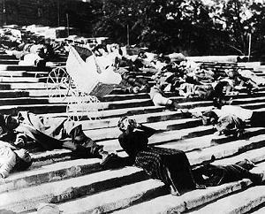

Sergei Eisenstein, Battleship Potemkin, 1925. The Odessa Stairs Massacre Scene.

From Tsar to Lenin, 1937. A remarkable documentary made in the U.S. in 1937 by a member of the American Socialist Party. The film was banned in the U.S. and then had to be reedited with a new voice-over to remove the "Communist propaganda," – it is a historical masterpiece on several levels.
https://www.youtube.com/watch?v=egWLsEzaKiI
Recommended: Warren Beatty, Reds (1981), based on John Reed’s (American journalist and socialist) 1919 book “Ten Days that Shook the World.” Rentable from several sites: Amazon, vod.canalplus.com, etc.
Georgi Derluguian, "Recasting Russia," New Left Review, 12, November-December 2001. http://newleftreview.org/?view=2354
R. G. Suny The Soviet Experiment: Russia, the USSR, and the Successor States (Oxford: Oxford U Press, 1998): Chapter 1, "The Final Crisis of Tsarism," pp. 1-32.
Recommended reading: On cultural hegemony (versus propaganda) in the media in interaction with the elites: Todd Gitlin, The Whole World is Watching. University of California Press, 1980 & 2003, Introduction (book sent via Cloud).

Week 2. The Radical Left Revolution, Civil War, Leninism, New Economic politcy (NEP), the Conservative Backlash, the end of the Avant-garde, and the Onset of Stalinism.
The Art leads the Historical Transformation (or Does It?). Cinema/ New Technology as a Revolutionary Tool
R.G. Suny, From „Building State Capitalism,“ p. 62 till p. 84.
Gökçeçiçek Savaşır and Ece Güleç Dergisi. „Art as a Political Act: The Russian Agit props of the 1920s,“
Güzel Sanatlar Fakültesi Sanat, Vol. 13, June 2020, pp. 301-333.
Richard Taylor. „Soviet Socialist Realism and the Cinema Avant-Garde,“ Studies in Comparative Communism, Vol. 17, No. 3/4 (Fall/Winter 1984-85), pp. 185-202.
Judith Mayne, Kino and the Woman Question: Feminism and Soviet Silent Film. Ohio S Uni Press, 1989. Chapters 1, 3 and 6.
“Cinema of Truth”. Art Collective and Montage Method as the “Eye” to Truth: Vertov, Pudovkin, Kuleshov, Dovzehnko, Eisenstein. The Proletkult (Against the Elitism of High Culture: „Art by the People, for the People“!)
S. Eisenstein, The Battleship Potemkin (1925) https://www.youtube.com/watch?v=2986SLGCgeE
Dziga Vertov, A Man with a Camera (1929) https://www.youtube.com/watch?v=cGYZ5847FiI
A/O. Dovzhenko, Earth (1930). On the collectivization of farms and peasants’ rebellion. Censored.
Vsevolod Pudovkin, Chess Fever (1925) https://www.youtube.com/watch?v=NdXmtc56rsM
Abram Room, Bed and Sofa (Third Burghers/Philistines‘ Street) (1927) https://www.youtube.com/watch?v=lNipP_F4MxI (women’s liberation - the goal and realities.
Lev Kuleshov, The Extraordinary Adventures of Mr. West in the Land of the Bolsheviks (1924) https://www.youtube.com/watch?v=Rqz53CnWZJA; Vsevolod Meyerhold’s Theatre and Theory of Biomechanics (1925): https://www.youtube.com/watch?v=dUUgaQqgBS0

Weeks 3: “Ripe” Stalinism: The Purges, Socialist Realism, and the End of the Revolution
R.G. Suny, Chapter 8 on "Culture Wars", pp. 195-212; The Stalin Revolution, Revolution from Above p. 217; War on the Peasants and the Final Opposition 218; Collectivization and Dekulakization 221; Famine in Ukraine 227; Stalin's Industrial Revolution 233; Class War on the Specialists, Centralization, Working Class, New Class of Bosses 235-246; The 2nd Five-Year Plan and Stakhanovism 247; Making the Socialist City 249; Building Stalinism, Retreat and the Great Purges 252-269 Socialist Realism and Movies with Stalin 269 – 275 Disciplining the Intelligentsia 276 Women and the Family 278.
A. Kemp-Welch, 'New Economic Policy in Culture' and Its Enemies, Journal of Contemporary History, 1978, Vol. 13, No. 3, pp. 449-465.
Boris Groys, The Total Art of Stalinism: Avant-garde, Aesthetic Dictatorship, and Beyond. 1992, Ch.1 The Russian Avant-Garde: The Leap over Progress & Ch. 2 Stalinist Art of Living.
Richard Taylor (1986): Boris Shumyatsky and the Soviet Cinema in the 1930s: ideology as mass entertainment, Historical Journal of Film, Radio and Television, 6:1, 43-64.
Alexander V. Prokhorov, Revisioning Aleksandrov’s Circus: Seventy Years of the Great Family (2007). The Russian Review, 66 (1), 1-4.
M. Belodubrovskaya, “Abram Room, A Strict Young Man, and the 1936 Campaign against Formalism in Soviet Cinema.” Slavic Review, Vol. 74, No. 2, 2015, pp. 311-333.
Denise J. Youngblood, The Fate of Soviet Popular Cinema during the Stalin Revolution, The Russian Review1991,vol 50,no.2, 148-162.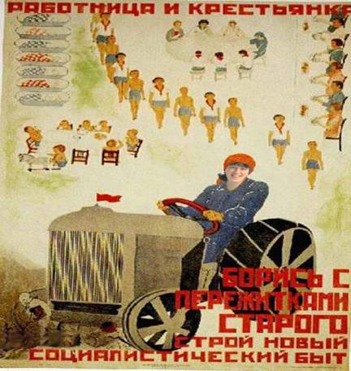
“Woman - Worker and Farmer! Fight the Remnants of Obsolete Traditions, Build the New Socialist Daily Life” (early Soviet poster).
Films:
Yakov Protazanov, The Forty-First (1927), the forbidden love between the Red Army woman sniper and her White Army aristocrat prisoner. https://www.youtube.com/watch?v=mRdoJxagITM&list=RDCMUCTKpdDNg- FgqRDg7TbIOgoQ&start_radio=1&rv=mRdoJxagITM&t=0
I recommend watching its G. Chukhray’s remake from 1956 (won international awards), and make a comparison with the original: https://www.youtube.com/watch?v=jMmwgEwsPd8
G. Aleksandrov, Circus (Tsirk), 1936. A remarkable (anti-American) propaganda piece (attention to racism and gender themes), but also a jolly Hollywood-mainstream style musical melodrama of that era, made during the deadliest period of Stalinist purges. https://www.youtube.com/watch?v=FVAN0A6OWE4
The Vasil’ev brothers, Chapaev (1934), Civil War heroic comedy drama. https://www.youtube.com/watch?v=T6KDKMgALps
Yakov Protazanov, St. Jorgen's Day (1930), religion, superstition and progress. https://www.youtube.com/watch?v=AMKGSiBbMOQ
Mikhail Chiaureli, The Great Dawn (1938) https://www.youtube.com/watch?v=QWAfSXR3ysY
Abram Room, A Strict Young Man (1935), filmed already in the heyday of Stalinism (miraculously, as it is strikingly critical of the nomenklatura’s corruption); https://www.youtube.com/watch?v=-xNsLIDIgJc

Week 4. World War Two, De-Stalinization, the Cold War, and the “Thaw” (the new generation of hopeful cosmopolitan “shestidesyatniki”). Everyday (and) Taste for Life.

Read the relevant part from G. Derluguian’s article “Recasting Russia.”
R.G. Suny: Communism versus Fascism p. 297, War in Europe 302, The Great Fatherland War 309, The Supreme Commander and the Road to Stalingrad 323, Endgame 329, The Cold War Begins 337, Yalta and Its Aftermath 343, Atomic Diplomacy 345, A New World Order 346, The Soviets in Eastern Europe 349, The Division of Europe 353, Late Stalinism at Home and Abroad 363, Stalinizing Eastern Europe 375, Cold War and Hot War, The Several Deaths of Stalin 387, The Soviets Enter the Nuclear Age 395, Peaceful Coexistence and Its Setbacks 397, Khrushchev in Crisis 399, Khrushchev and the Politics of Reform 404, The Thaw and Destalinization 404, The Arms Race 411.
Denise J. Youngblood, A War Remembered: Soviet Films of the Great Patriotic War, The American Historical Review, Vol. 106, No. 3, pp. 839-856.
V. Prokhorov (2013). Cinema of the Thaw (1953-1967), in Rimgaila Salys (Ed.), The Russian Cinema Reader: Vol. II, The Thaw to the Present (pp. 14-33). Acad. Studies Press. https://scholarworks.wm.edu/asbookchapters/86
E. Papazian, "Ethnography, Incongruity, History.: Soviet poetic Cinema, The Russian review, vol. 82, Issue1, 2023, pp. 68-90.
Recommended:
Katerina Gerasimova, “Public Privacy in the Communal Apartment,” in Socialist Spaces: Sites of Everyday Life in the Eastern Bloc, ed. David Crowley and Susan E. Reid (Oxford: Berg, 2002), 207–230.
Stephen Lovell. (2002). Soviet Exurbia: Dachas in Postwar Russia. In D. Crowley, & S. S. Reid (Eds.), Socialist Spaces: Sites of Everyday Lige in the Eastern Bloc (pp. 105 - 121).
Films during and about the Great Fatherland War:
Yulii Raizman Mashen'ka, (1942): https://www.youtube.com/watch?v=Oo2Wo1ppsLI
Mark Donskoy, Rainbow (1944) (unfortunately without subtitles, but perhaps you can find them with some extra skill 🙂)
https://www.kinoglaz.fr/index.php?lang=gb&page=fiche_film&num=661

During the war and its immediate aftermath, very few films were made, for several reasons worth discussing. The most popular films about WWII made more than a decade and almost two decades later: Mikhail Chiaureli, The Fall of Berlin, 1950. Heavy propaganda. https://www.youtube.com/watch?v=AJyi2BJnmO4
Mikhail Kalatozov, The Cranes are Flying (won Palme d'Or in Cannes), 1957: https://russianfilmhub.com/movies/the-cranes-are-flying-1957/
Sergey Bondarchuk Fate of a Man,1959: https://sovietmoviesonline.com/drama/sudba-cheloveka Grigoriy Chukhray, Ballad of a Soldier (1959), https://sovietmoviesonline.com/melodrama/ballada-o-soldate https://russianfilmhub.com/movies/ballad-of-a-soldier-1959/
Stanislav Rostotsky, The Dawns are Quiet Here (1972), in two parts on Soviet Cinema site.
About a female military training squad and “gender trouble” with men leading them.
COMPARE TO:
Larisa Shepitko, The Wings, 1966. A story of a woman pilot considered a hero of the state. https://www.youtube.com/watch?v=Q3xqC1h-eB8
Grigoriy Chukhray, Clear Skies 1961; the first film (of the "Thaw" period) depicting Stalinist repressions. https://sovietmoviesonline.com/melodrama/chistoe-nebo
Andrei Tarkovsky, Ivan's Childhood (1962).
Marlen Khutsiev, I am Twenty (Lenin’s Factory Gate), 1965. Film in two parts. Censored version: https://www.youtube.com/watch?v=AG7YqF3WjFE; https://www.youtube.com/watch?v=p4VlqzBMgDs Now, the uncensored/ full/original version, which, unfortunately, exists only with French subtitles. https://www.youtube.com/watch?v=6MNcVC-KB3A
https://www.youtube.com/watch?v=HeFPXcwUp0Q
You will easily find the differences from the censored version. The length of the avant-garde poets' evening at the Institute of Polytechnics (a 1962 documentary footage, with the participation, toward the end, of Soviet Army soldiers in the audience): 37-55 min. In the censored version it was cut to just about 5 min.
50-52 min. Bulat Okudzhava, a famous songwriter plays and sings his ‘Sentimental March.’
The dialogue of Seryozha with Anya’s father was also changed in one detail. Where Anya is sarcastically intervening in their conversation -- in the non-censored version she answers her father that Seryozha wants to become an ‘astronaut,’ and in the censored version – ‘a movie star.’
Finally, and most importantly: the scene with the ghost of the father and dead soldiers (his comrades killed in the war), was completely re-done, the dialogue was changed, and a different actor was taken to play the father! 1:44-1:56 min. To analyze why. Also, pay attention to the faces of dead soldiers in the non-censored version, where in the end Seryozha sees among them himself and his two friends! An easy to read review of the film
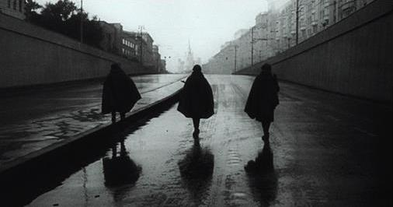
https://www.wnyc.org/story/i-am-twenty-soviet-new-wave-filmmaking-khrushchev
-thaw/
Kira Muratova, Brief encounters, 1967. A legendary, defiantly anti-mainstream director, both during and after the Soviet age (she died several years ago in Odessa where she lived and worked in the local studio all her life).
Marlen Khutsiev, I am Twenty (Lenin’s Factory Gate), 1965, opening scene. Severely censored at the time.

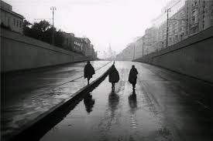
Week 5: Ethnicity, Nationality, Gender, and Everyday Life from the 1920s till Brezhnev’s era of Stagnation (Zastoi) and “Western” Consumerism
Read the relevant parts from Derluguian.
Yuri Slezkine, The USSR as a Communal Apartment, or How a Socialist State Promoted Ethnic Particularism, Slavic Review 52, no. 2 (Summer 1994), pp. 414-452.
Terry Martin. The Origins of Soviet Ethnic Cleansing, The Journal of Modern History , December 1998, Vol. 70, No. 4, 1998), pp. 813-861.
Yulia Gradskova, Speaking for Those "Backward": Gender and Ethnic Minorities in Soviet Silent Films. Region, Vol. 2, No. 2 (2013), pp. 201-220.
Lynne Atwood, Red Women on the Silver Screen. Pandora Press, 1993. Read chapters by M. Turovskaya and O. Bulgakova (while the whole book, including the general introduction is excellent);
David Crowley and Susan E. Reid, Socialist Spaces: Sites of Everyday Life in the Eastern Bloc.
Recommended: Samuel J. Hirst, Soviet Orientalism across Borders: Documentary Film for the Turkish Republic. Kritika: Explorations in Russian and Eurasian History, Volume 18, Number 1, Winter 2017, pp. 35-61.
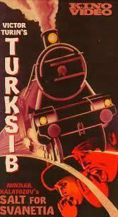

Viktor Turin and Viktor Shklovsky, poster for the documentary
TURKSIB, the building of Turkestan– Siberia Railway, 1929.
Industrialization as the Way Out of Backwardness and Discrimination for Minority Nations and for Inclusion in the Soviet State/ System.

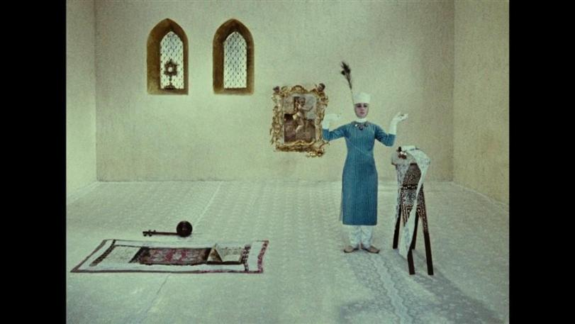
Sergey Parajanov, The Colour of Pomegranates, 1969. New Avant-Garde Approaches to Ethnic History.

Films:
Dziga Vertov, A Sixth Part of the World (1926). Subtitles not great.
https://www.youtube.com/watch?v=zfhCmU5R9-Q
Viktor Turin and Viktor Shklovsky, TURKSIB, the building of Turkestan–Siberia Railway. 1929. Short version with English voiceover. https://www.youtube.com/watch?v=RSEQhiIqkuE
Ali Khamraev, "White, White Storks" (1966) (Attn: Central Asia, gender issues!)
https://makeminecriterion.wordpress.com/2018/08/27/white-white-storks-ali-khamraev-1966/ Belong also to the period of “Thaw.”
Ali Khamraev, “Tryptich” (1980) (post-war rebuilding, gender/ women’s independence, Central Asia)
Sergey Parajanov, Shadows of Forgotten Ancestors, 1965; The Colour of Pomegranates, 1968. Belong also to the “Thaw.”
Nationality/ ethnicity comedies/ ethnic stereotyping:
Georgiy Daneliya. Mimino (1977). https://www.youtube.com/watch?v=P4k2LNPRV-0
“Happy-time comedies” of the “Stagnation” pariod (“the future of nostalgia”):
Eldar Ryazanov, The Irony of Fate or Have a Great Bath! 1975. A blockbuster then, and a cult nostalgia film today. By the same director: “The Garage” (1979), mild satire.
Related to the films, see on Soviet residential architecture and cinema: https://eefb.org/special-issue/russian- architecture-issue/russian-architecture-issue/
Vladimir Men’shov, Moscow Does Not Believe in Tears (women’s comedy drama), 1979, 1981 American Academy Award for Best Foreign Film. https://www.youtube.com/watch?v=NTWA_7-ld_U
Other popular action/ melodrama comedies from the 1970s: Ivan Vasil’evich Changes his Profession, The Prisoner of the Caucasus, Diamond’s Hand.

Week 6. What Was Socialism and Why Did It Fall? “Perestroika” & “Glasnost”: Democracy and the Breakdown of the State. The Problematic Lack of Predictability of the Fall of Communist Realm
Read the relevant parts from Derluguian’s “Recasting Russia.”
Neil Robinson, Explaining Soviet collapse (2017) (excerpt from the book): https://core.ac.uk/download/pdf/92425832.pdf
R. G. Suny, pp. 481-524 (until the war in Chechnya).
Mary McAuley, Soviet Politics 1917-1991 (Oxford University Press, 1992), Ch. 7, Perestroika and the End of Party Rule, pp. 89-106.
Katherine Verdery. What Was Socialism and Why Did It Fall & A Transition from Socialism to Feudalism? Thoughts on the Postsocialist State. In: Verdery, K. What Was Socialism and What Comes Next? Princeton: Princeton U Press, pp. 19-38 and 204–228.
Aleksei Yurchak. Soviet Hegemony of Form: Everything Was Forever, Until It Was No More. 2003. Comparative Studies in Society and History, Vol. 45, No. 3 (Jul., 2003), pp. 480-510. http://blc.berkeley.edu/Yurchak Hegemony_of_form.pdf
A. Horton and M. Brashinsky: "The Zero Hour: Glasnost and Soviet cinema in transition." (1992): Chapter 1. Back to the Present: (Re)presenting the Soviet Past in Feature Films 33; Chapter 2. "We Are Your Children": Soviet Youth, Cinema, and Changing Values; Chapter 5. Down with Stuttering: Soviet Popular Genres and the New Film Language 157, Chapter 6. From Accusatory to Joyful Laughter: Restructuring the Soviet Comic Satiric Muse 187, Chapter 7. The Islands of the Continent: A Revised Map tor Ethnic Cinema.
Birgit Beumers, 'Russia on Reels,' (1999). Pages/ chapters: "To Moscow! To Moscow? The Russian Hero and the Loss of the Centre", and short speeches by Sergei Selianov, Daniil Dondurei, Nikita Mikhalkov, Tatiana Moskvina, David Gillespie, and Natasha Zhuravkina.Pp.: 25-33, 43-56, 76-90, 105-113, and 144-160. Useful Notes are on 187-205.

Films:
On facing the Stalinist Terror: Aleksandr Proshkin, "The Cold Summer of 1953", 1987; Tengiz Abuladze, "Repentance", 1987. Aleksei German, “My Friend Ivan Lapshin,” 1985.
On youth, the clash of generational values, and social class: Vasiliy Pikul’, "Little Vera", 1988.
On changing values in work and class (conflict) (pride in work, status of workers/ intellectuals artists' split): Pavel Lungin, "Taxi Blues,” 1990; Ibolya Fekete, Bolshe Vita, 1996).
On the disintegration of social-moral values: Kira Muratova, "The Asthenic Syndrome,"1989.
On the uncommonness of the transition looked back after decades (memory/ nostalgia/ truth/ looking from the outside): “Trauma Zone” 1985 to 1989 (2022) BBC series by Adam Curtis:
https://www.youtube.com/playlist?list=PLGDByvdY5CHX_BTvG2X4vPrQfgqlSwSy5 (Part 1, all 7 parts available)
Chantal Akerman, From the East (D’ Est), documentary, 1993 (find).

Weeks 7: The End of the “Westernizing” Enthusiasm and the Putin Era. ‘Transition’ to What? Wars in Chechnya. War on Ukraine.
Anna Politkovskaya, A small corner of hell: dispatches from Chechnya (Chicago: University of Chicago Press, 2003). Read Introduction chapter by Georgi Derluguian.
Ekaterina Makhotina, Nostalgia, Pride and Shame: The Many Faces of Stalin in contemporary Russia, Cultures of History Forum, 23. Jan 2018, University of Jena. http://www.cultures-of-history.uni- jena.de/debates/russia/nostalgia-pride-and-shame-the-many-faces-of-stalin-in-contemporary-russia/#part3 Anne Le Huérou , Aude Merlin, et al., eds. Chechnya at War and Beyond, eds. Routledgde, 2014.
Chapters of interest: Introduction; Ramzan Kadyrov’s ‘Illiberal’ Peace in Chechnya, John Russell. The North Caucasus Insurgency: Understanding the Chechen Rebels in the Context of the Caucasus Emirate, Jean-F Ratelle..
Aleksei Yurchak, "Little Green Men: Russia, Ukraine and Post-Soviet Sovereignty," Anthropoliteia, March ,, 2014. https://anthropoliteia.net/2014/03/31/little-green-men-russia-ukraine-and-post-soviet-sovereignty/
Tatiana Zhurzhenko, How War Is Rebordering Ukraine. Current History, 2024, 123 (855): 249–255.
https://online.ucpress.edu/currenthistory/article/123/855/249/203276/How-War-Is-Rebordering-Ukraine
The Putin-Trump “Deal”: https://www.sciencespo.fr/en/news/assessing-the-damage-of-a-trump-putin-deal/
War on Ukraine
Igor Torbakov, Deadly Illusions: The Ukraine War and Russian Historical Imagination.
May 1, 2023. https://therussiaprogram.org/onlinepaper-3
Die Herausgeber_innen der feministischen studien. The Ukrainian Feminists in the Situation of War: “A Significant Progress in Gender Equality”, or a Turn to the Right? Apr. 17, 2025.
https://blog.feministische-studien.de/2025/04/the-ukrainian-feminists-in-the-situation-of-war-a-significant-progress-in-gender-equality-or-a-turn-to-the-right/
Olena Strelnyk, Gender, War, and Forced Displacement: Social Perceptions and Attitudes. War, Migration, Memory: Perspectives on Russia's War Against Ukraine, edited by V. Sereda, Bielefeld: transcript Verlag, 2024, pp. 263-280.
Marta Havryshko: Ukraine Trapped in Narratives Designed for a Long War. January 1, 2026. https://www.youtube.com/watch?v=RxJXYH_RLOc
Ianina Prudenko. Mythogenesis: Kyiv | audio visual installation. Art/ Research project by Ukrainian curator Ianina Prudenko dedicated to the deconstruction of the myth of contemporary ATO hero. https://www.mediaartarchive.org.ua/eng/media-art/mifogenez/
Tatiana Zhurzhenko (2025). Ukrainian Memory Laws and Decommunization Policies from the Euromaidan to the Full-Scale Russian Invasion. In: Uladzislau Belavusau e.a. (eds.). The Politics of Memory Laws. Russia, Ukraine and Beyond. Bloomsbury, pp. 99-124.

Conference on Ethics in Documentary Filmmaking / Sergei Loznitsa on making films on Ukraine. Masterclass, Ji.hlava International Documentary Film Festival, 2023.
https://www.youtube.com/watch?v=DPRn9XajJro

Selfies with Stalin today. Joseph Stalin’s bust at the Kremlin Wall (placed in 1970).

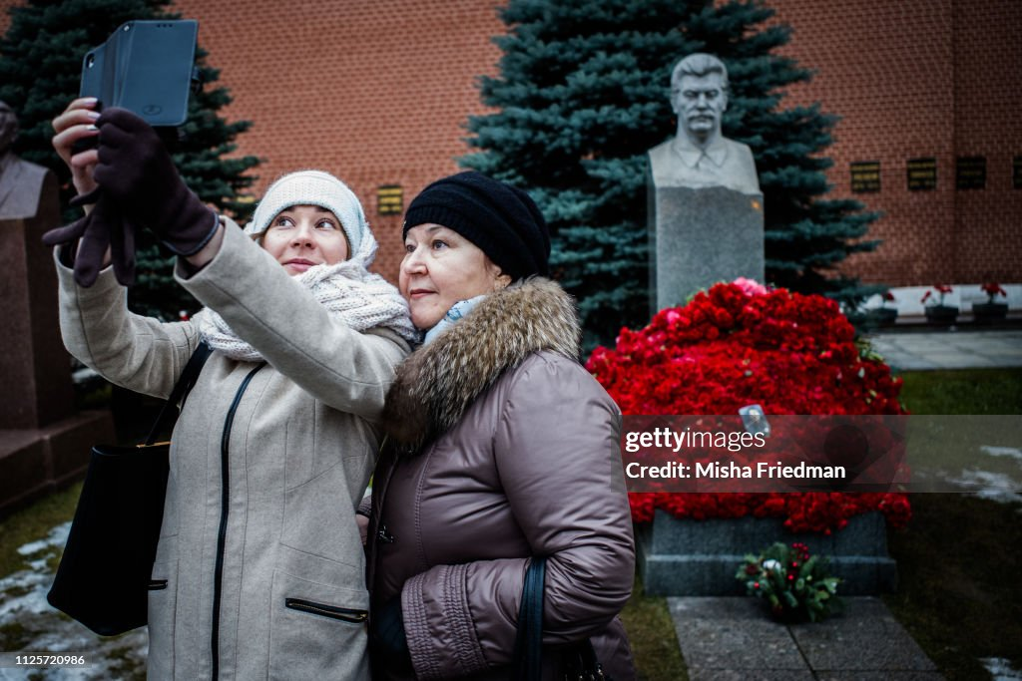

Week 8 Post-Soviet Nostalgias: Imperial-Russian, Commodifying, and Reflective. Youth Culture, Gender and Repatriarchalization. Protests and Discontents
“Reflective nostalgia does not follow a single plot but explores ways of inhabiting many places at once and imagining
different time zones; it loves details, not symbols. At best, reflective nostalgia can present an ethical and creative challenge, not merely a pretext for midnight melancholias.” (Svetlana Boym, The Future of Nostalgia. 2001: xviii).

Alexei Yurchak. “Gagarin and the Rave Kids: Transforming Power, Identity and Aesthetics in Post-Soviet Night-Life” In: Adele Barker, ed. Consuming Russia: Popular Culture, Sex and Society. Durham: Duke University Press, 1999, pp.76–109.
Nadkarni Maya and Olga Shevchenko. The Politics of Nostalgia: A Case for Comparative Analysis of Post-socialist Practices, 1-2, Ab İmperio, Issue 2/2004.
Susan Larsen, Melodramatic Masculinity, National Identity, and the Stalinist Past in Post-Soviet Cinema, Studies in 20th Century Literature, 24: 1, 85-120, 2000. Susan Larsen, National Identity, Cultural Authority, and the Post-Soviet Blockbuster: Nikita Mikhalkov and Aleksei Balabanov, Slavic Review, 2003, Vol. 62, 3, 491-511.
R. Salys, Three-Rib Circus: Women and Historical Discourse in “Rebro Adama” (Adam’s Rib), The Russian Review, Vol. 60, No. 4 (Oct., 2001), pp. 614-630.
Olha Kofman, Freed by Ideology, Imprisoned by reality, Dissertation (attached), read pp. 95-109.
Yana Hashamova, Post-Soviet Russian Film and the Trauma of Globalization, Consumption, Markets and Culture, Volume 7, Number 1 /March 2004, pp.53-68, and/or Hashamova, Y., (2006). Castrated Patriarchy, Violence, and Gender Hierarchies in Post-Soviet Film. In: Goscilo, H., & Lanoux, A. (eds.), Gender and national identity in 20th century Russian culture. Northern Illinois Uni Press.
Mischa Gabowitsch, Memory Activism in Post-Soviet Spaces. 2023. The Routledge Handbook of Memory Activism.
Zdravomyslova, E. (2014). Gender’s crooked path: Feminism confronts Russian patriarchy. Current Sociology, 62(2), 253-270.
Bernstein, A. (2013) An Inadvertent Sacrifice: Body Politics and Sovereign Power in the Pussy Riot Affair, Critical Enquiry, 40(1), pp. 220-241.
Elena Omelchenko and Guzel Sabirova (2016). Youth Cultures in Contemporary Russia: Memory, Politics, Solidarities, in Matthias Schwartz, Heike Winkel, eds., Eastern European Youth Cultures in a Global Context, Palgrave, pp. 253-270.
Ksenia Robbe & Zavadski, Andrei (2024/2023) ‘C’mon, turn Swan Lake on’: Memories of the 1990s at the Belarusian protests of 2020. Studies in Russian, Eurasian and Central European New Media, 22: 115–141.

Recommended: Buckler, Julie A. 2009. What comes after “Post-Soviet” in Russian studies? PMLA 124 (1):
251-263. https://dash.harvard.edu/bitstream/handle/1/4341694/Buckler_WhatComes.pdf (see refs. to S. Oushakine’s “apahasia” (explain the meaning).
Stephen M. Norris, A Kiss for the KGB: Putin as Cinematic Hero, in Brigitte Beumers, (ed.) Russia’s New Fin de Siècle: Contemporary Culture Between Past and Present, University of Chicago Press, 2013.
Erpyleva, S. 2018. The Politicisation of Russian Youth. New Eastern Europe. Freedom House. 2019. Russia’s War on Youth. Available at: https://freedomhouse.org/article/russias-war-youth

Films , starting from the “Perestroika” and “Glasnost” (most are on Soviet/Russian Cinema site). In blue – mandatory.
On facing the Stalinist Terror:
A. Proshkin, "The Cold Summer of 1953", 1987; T. Abuladze, "Repentance", 1987; A. German, “My Friend Ivan Lapshin,” 1985.
On the changing values and social/ generational conflict, (status of work/ers/ and intellectuals):;

V. Pikul’, "Little Vera" 1988; P. Lungin, "Taxi Blues,” 1990; K. Muratova, "The Asthenic Syndrome,"1989.
S. Bodrov, Prisoner of the Mountain, 1994.
Vladimir Khotinenko, The Muslim (Musul’man), 1995.https://www.youtube.com/watch?v=0dZ-Xl1dTuc&t=3176s
N. Mikhalkov, Burnt by the Sun, 1994, and The Barber of Siberia, 1998.
A. Rogozhkin, Peculiarities of the National Hunt, 1995.
A. Balabanov, War (also for youth topics), 2000; and Brother-2 (also for violence/crime and Soviet- US “competition”), 2002.
Aleksandr Sokurov, Russian Arc. 2002.
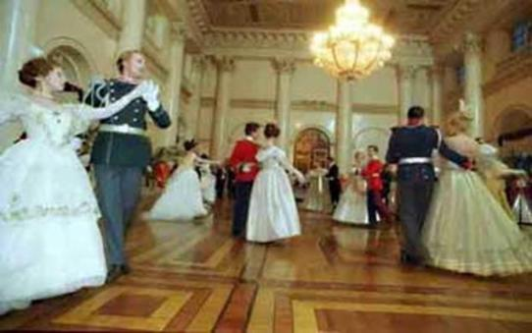

Russian Ark, Sokurov, 2002.
A. Sokurov, Alexandra, 2007. (grassroots/ women’s perspective on the Chechen wars).
Viacheslav Kristofovich, Lonely Woman Seeks Lifetime Companion, 1986. Viacheslav Krishtofovich, Adam's Rib (Rebro Adama), 1990.
Larisa Sadilova, From Lilya, with Love (S lyubovyu, Lilya), 2003. Lukas Moodysson, Lilya 4-Ever, 2002.
Gennadi Sidorov, Old Women (Starukhi), 2003.
Tverdovsky, Zoology, 2016; Jumpman, 2018; Conference, 2020.
Bakhtyar Khudojnazarov, The Fancy Suit (Shik), 2003 (have on DVD).
Oksana Bychkova, Piter FM (2006) (have on DVD).
A. Zvyagintsev, The Return, 2003.
Anna Melikyan, Mermaid (Rusalka), 2007.
K. Serebrennikov, Uchenik (Student) (on clericalization), 2016&Summer (Leto), 2018 (nostalgia/ pop-rock music).
I. Voloshin, Olympus Inferno, 2008.
A. Zvyagintsev, Leviathan, 2014.
N. Merkulova, A. Chupov, Captain Volkonogov Escaped, 2021.
P. Talankin and D. Borenstein, Mr. Nobody Against Putin. 2025 (Oscar-Winner !)
Serhiy Loznitsa, Donbass, 2018. (unavailable?).
Conference on Ethics in Documentary Filmmaking / Sergei Loznitsa, filmmaker, on making films on Ukraine. Masterclass, Ji.hlava International Documentary Film Festival, 2023. https://www.youtube.com/watch?v=DPRn9XajJro
ARTE documentary on Donbass, voices from the occupied territory, 2023. https://www.youtube.com/watch?v=_sw65qMESuk
UNHCR/ Ukrainian refugees in Berlin: “Uprooted”, https://www.unhcr.org/ua/en/46227-ukrainian-refugees- depict-trauma-of-fleeing-war-in-new-short-film.html
Olga Chernykh, 2023. Foto na pam’iat’ / A Picture to Remember (Ukraine, France, Germany).
Benoît Bringer (2023). The Rise of Wagner, France, contact: Aïdan Aziz Mediawan aaziz@mediawan.com
Newer films, dealing with Russian youth (euphoria, anxiety and hopes; rebellion; music, dystopia).
Some call these films “a cry of the silenced generation.”
TOLYATTI ADRIFT , Laura Sistero, Spain & France, 2022. https://www.beldocs.rs/product/gluvarenje-u-toljatiju/
SILENT SUN OF RUSSIA, Sybilla Tuxen, Denmark, 2023. https://www.beldocs.rs/product/nemo-sunce-rusije/
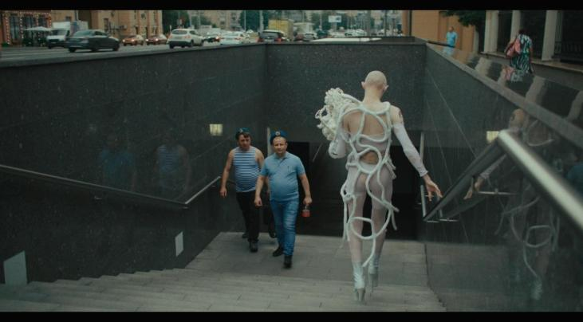
How to save a dead friend. Marusya Syroechkovskaya, Sweden, France, Germany, Norway, 2022. https://www.beldocs.rs/.../kako-spasiti-mrtvog-prijatelja/
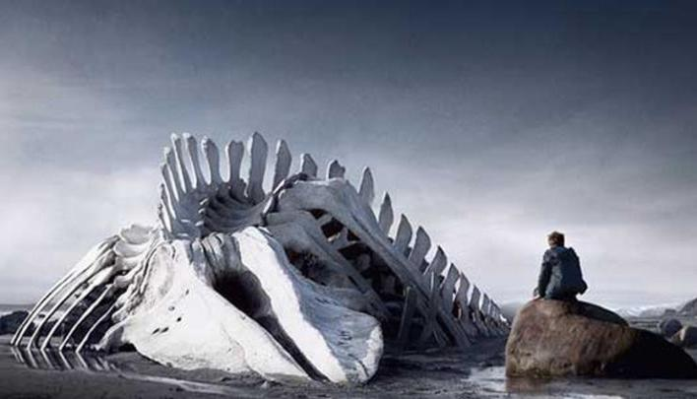
Agniia Galdanova, Queendom, 2022.
Zvyagintsev, Leviathan, 2014.
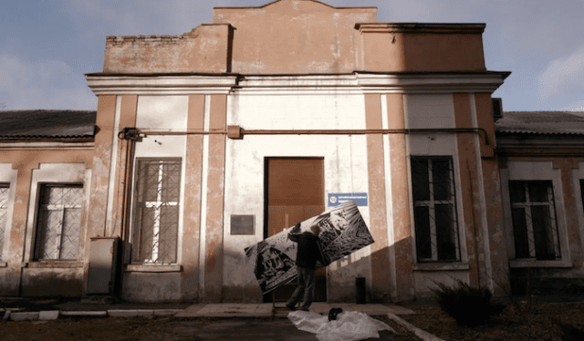
Olga Chernykh, 2023. A Picture to Remember.

